CAR PARK BENEFIT CONFIGURATIONS

(CAG benefit configuration for example)

(1) SYSTEM CODE > CONFIGURATION >> 1st3DigitsIUForMotorcycles

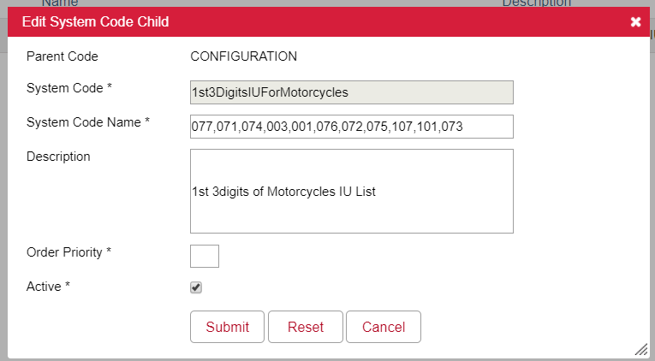

(2) SYSTEM CODE > Carpark_MotorCycle_HourlyCharges

(3) SYSTEM CODE > Carpark_MotorCar_HourlyCharges



(4) SYSTEM CODE > VoucherType >> FreeParkingVouchers

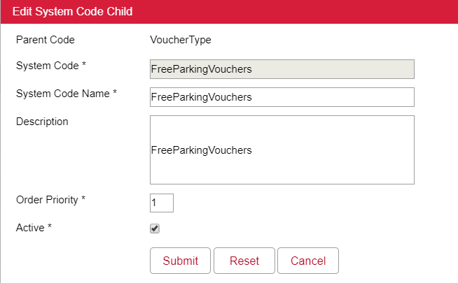

(5) VOUCHER TYPE > PCP2H, GCP1H

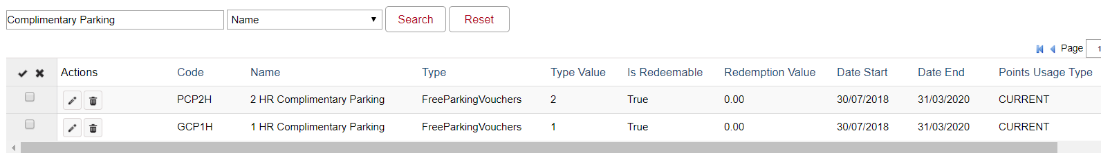

(6) REWARD CAMPAIGN

SALES CAMPAIGN(S) Reward Free Parking Voucher setup

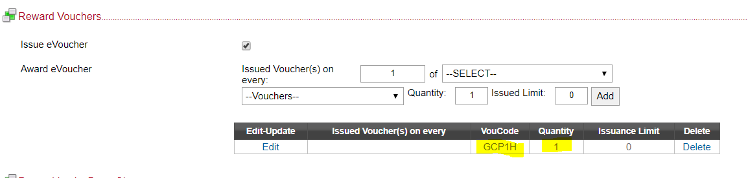

**Calculate benefit carpark $ (Voucher)**

1. Get IU number and identify vehicle type with systemCode-1st3DigitsIUForMotorcycles setting
2. Get Hourly rate of vehicle type with systemCode- Carpark_MotorCycle_HourlyCharges / Carpark_MotorCar_HourlyCharges
3. Calcuate Benefit Value by benefit hours (Voucher Type’s TypeValue)

Hourly rate by vehicle type * Hours

CAR PARK BENEFIT WILL BE EXPIRED ON THE SAME DAY OF ISSUE DATE.

ONLY THE BENEFIT(S) WHICH ISSUED BY THE CAMPAIGN, ABLE TO SYNC TO CARPARK VENDOR.